**Dynamics of *Teleaulax*-like cryptophytes during the decline of a red water bloom**

**in the Columbia River Estuary**

*Authors:*

Maria Hamilton 1,2, Gwenn M. M. Hennon 1,3, Rhonda Morales 1, Joseph Needoba 4, Tawnya D. Peterson 4, Megan Schatz 1, Jarred Swalwell 1, E. Virginia Armbrust 1, Francois Ribalet 1*

*Affiliations:*

1 School of Oceanography, University of Washington, Box 357940, Seattle, WA 98195 USA

2 Present address: Ocean Sciences Department, UC Santa Cruz, 1156 High Street, Santa Cruz, CA 95064

3 Lamont-Doherty Earth Observatory, Columbia University, 61 Route 9w, Palisades, NY 10964

4 Institute of Environmental Health, Oregon Health & Science University, 3181 SW Sam Jackson Park Rd., Portland, OR 97239 USA

* Corresponding author: [ribalet@uw.edu](mailto:ribalet@uw.edu)

**ABSTRACT**

The mixotrophic ciliate, *Mesodinium rubrum,* is a globally distributed ciliate that relies on the acquisition and use of chloroplasts derived from its cryptophyte prey. The ecology and physiology of the cryptophytes is not well known, nor is it clear how their growth influences *M. rubrum* blooms. A 4-week survey was conducted in the Columbia River estuary in 2013 during the decline of the annual *M. rubrum* bloom to better understand how environmental factors influence the dynamics of the cryptophyte prey, *Teleaulax amphioxeia*. Abundances and division rates of free-living *Teleaulax*-like cryptophytes were continuously monitored using flow cytometry. Cryptophyte division rates, estimated *in situ* for the first time using a size-structured division rate model, ranged from 0.2 to 1.5 d-1, with the highest rates observed in accordance with high abundances*.* These division rates were positively correlated with concentrations of dissolved inorganic nitrogen and phosphorus, suggesting nutrient availability limited the growth of *Teleaulax*-like cryptophytesat that time. Assuming a minimum ingestion rate of ~1 cryptophyte ciliate-¹ day-¹, the growth of *M. rubrum* may have been limited by the low abundance of *Teleaulax*-like cryptophytes during the *M. rubrum* bloom decline. Our results highlight the importance of prey availability for understanding the dynamics of red water blooms.

Key words: cryptophytes; *Teleaulax; Mesodinium rubrum;* division rates; SeaFlow.

**INTRODUCTION**

The cosmopolitan coastal ciliate, *Mesodinium rubrum* (=*Myrionecta rubra*) (Lohmann 1908, Jankowski 1976), is among the marine microzooplankton that acquire and temporarily maintain the plastids of their cryptophyte algal prey, in this case, *Teleaulax amphioxeia* (Herfort et al. 2011). This relationship allows the ciliate to function as a mixotroph, capable of employing both phagotrophy and photosynthesis, to acquire carbon (Gustafson et al. 2000, Qiu et al. 2016). A variety of associations have been observed *in situ* and in laboratory cultures of *M. rubrum*, including the harboring of plastids and other organelles (Gustafson et al. 2000, Johnson et al. 2007). Although *M. rubrum* populationsare important primary producers in many coastal and estuarine systems (Crawford 1989, Stoecker et al. 1989, Herfort et al. 2012), little is known about the ecology and physiology of the free-living cryptophyte prey and its influence on *Mesodinium* bloom dynamics.

Massive *M. rubrum* blooms (i.e., red water blooms) occur each summer in the Columbia River estuary (Herfort et al. 2011). The blooms persist for several weeks during the late summer and early autumn and shift the trophic status of the estuary from net heterotrophic to net autotrophic (Herfort et al. 2012). The annual *M. rubrum* bloom appears to be initiated during summer neap tides (Herfort et al. 2011) when both tidal forcing and the seasonality of freshwater discharge result in an extended summer saltwater intrusion (Chawla et al. 2008). The blooms appear to start in Baker Bay where a shallow depth and long water-retention time favor the persistence of high cell abundances (>100 cells mL-1) achieved through rapid rates of cell division (1.2–3.1 d-1) of *M. rubrum*. Within a few weeks the initial blooms spread throughout the main estuary (Herfort et al. 2011). A decline in the abundance of small (<5 µm) and free-living *Teleaulax* cells coincided with an increase in *M. rubrum* abundance observed in the estuary in 2011 (Peterson et al. 2013) which suggests a direct link between consumption of the cryptophyte prey and the initiation of *M. rubrum* blooms. Further evidence of a connection between prey populations and the development of *M. rubrum* blooms has been observed elsewhere including in an Antarctic saline lake where an increase in the abundance of cryptophytes preceded the increase in abundance of *M. rubrum* (van den Hoff & Bell 2015). In Jinhae Bay, Korea, peaks of cryptophyte abundance coincided with those of *M. rubrum* (Kim et al. 2007), while the opposite occurred for a bloom in the Chesapeake Bay (Johnson et al. 2013). However, the factors that influence cryptophyte prey population dynamics remain poorly understood in these systems.

To investigate the influence of prey population dynamics on *M. rubrum* blooms, we examined patterns in abundances and division rates for free-living *T. amphioxeia*. Numerous factors influence cell abundances, including cell division, cell mortality, and physical advective transport. In a dynamic system such as the Columbia River estuary, where semi-diurnal tides dramatically change phytoplankton community composition (Fortunato et al. 2012), a high-frequency sampling approach is required to properly capture changes in abundances over time. Hourly measurements of the population size structure can be used to estimate division rates based on changes in cell size distribution over the course of a day (Sosik et al. 2003, Hunter-Cevera et al. 2014, Ribalet et al. 2015). This method eliminates many of the difficulties and biases associated with the determination of cell division rates using discrete sampling techniques (Laws 2013).

Here we use the SeaFlow (Swalwell et al. 2011), a continuous flow cytometer, to determine cryptophyte abundances and division rates both in the laboratory and during a 4-week survey carried out in 2013. Dissolved nutrient concentrations, salinity, temperature, irradiance, and abundances of cryptophytes and *M. rubrum* were measured during the decline of a red water bloom in the Columbia River estuary. Daily division rates of cryptophytes were calculated from the change of size distribution over a 24-h period using a size-structured division rate model (Sosik et al. 2003, Ribalet et al. 2015). These division rates were then linked to environmental conditions in the estuary to identify potential growth limiting factors. The abundances of the cryptophyte population were compared with abundances of *M. rubrum* to examine the influence of prey cryptophytes on the dynamics of red water blooms.

**METHODS**

**Study Area**

Samples were collected at 2.4 m depth for 1 month, 4 days a week, from September 11th to October 2nd 2013 from a continuous seawater flow-through system at SATURN-03, a fixed station located at the end of a dock in Hammond, OR (**Fig. S1**) (Baptista et al. 2015). Discrete samples for the determination of cell abundances and size class structure of the population were also collected at the station during the turn of the high tide (i.e., at slack water).

**In situ monitoring**

Water temperature and salinity were measured at SATURN-03 using a SeaBird 37 Conductivity-Temperature (CT) meter, coupled with a chlorophyll and phycoerythrin fluorometer (Turner designs), deployed in-line with the pumped water system that alternates between 3 depths (see Baptista et al (2015) for description). Water measurements were extracted for the 2.4-m depth corresponding to the flow cytometry sampling described below. Photosynthetic Active Radiation (PAR) data was obtained from Desdemona Sands Light mooring, located 3 km north of SATURN-03.

**Dissolved inorganic nutrients**

Duplicate nutrient samples were collected in temporary bottles from water pumped to the surface at SATURN-03 and then filtered into 30 ml HDPE storage bottles. All bottles for collection and storage of samples, syringes, and filter housings were washed with 10 % hydrochloric acid and rinsed 3 times with deionized water before use. Bottles, syringes, and filter housings were dried, capped, and stored in clean Ziploc bags until use. Collection bottles were rinsed three times with sample and filled by gently pushing sample through a clean Swinnex filter holder loaded with a combusted 25-mm glass fiber filter (Whatman GF/F) using a clean 60-ml syringe. Storage bottles were rinsed three times with filtered sample before final filling; samples were frozen upright at −20 °C.

Nutrient concentrations were determined using an Astoria Analyzer (Astoria-Pacific, Clackamas, OR, USA). Before analysis, all samples were thawed in a water bath (55 °C) and cooled to room temperature. Nitrate, nitrite, ammonium, and orthophosphate were determined using manufacturer recommended methodology (Armstrong et al. 1967), EPA 1984, EPA 1997). These methods have minimum detection limits (MDL) of 0.5, 0.2, 0.3, 0.2 μM, respectively. Quality assurance was maintained by running certified reference material (ERA catalog #4023).

**Determination ofcryptophyte cell abundance and cell size**

Continuous measurements of cryptophyte abundances and cell size were made using SeaFlow (Swalwell et al. 2011). The instrument was equipped with a 457-nm 300-mW laser (Melles Griot). Forward light scatter (a proxy for cell size), red, and orange fluorescence were collected using a 457–50 bandpass filter, 692–40 band-pass filter, and 572–27 bandpass filter, respectively. Seawater was prefiltered through a 100-µm stainless steel mesh (to eliminate large particles) prior to analysis. The flow rate of the water stream was set at 15 mL min−1 through a 200-µm nozzle. A programmable syringe pump (Cavro XP3000, Hamilton Company) continuously injected fluorescent microspheres (1 µm, Polysciences) into the water stream as an internal standard. Data were recorded to file in three minute intervals. Data were analyzed using the R package *Popcycle* version 0.2 (available on GitHub https://github.com/uwescience/popcycle). A sequential bivariate manual gating scheme was used to identify the cryptophyte population based on forward light scatter, high orange (assumed to represent phycoerythrin-containing cells) and high red fluorescence measurements.

To confirm the identification of cryptophyte cells, discrete samples for flow cytometry were collected once a day during slack tide. Flow cytometry samples were fixed with 0.25% glutaraldehyde and stored at -80 ºC. and analyzed six months after collection using a BD Influx cell sorter equipped with a 488-nm 200-mW laser (Coherent). One hundred cells from the cryptophyte population identified by flow cytometry were sorted onto a glass slide and examined under a Nikon Eclipse 80i epifluorescence microscope at 400x magnification then photographed using a Qimaging MicroPublisher 3.3 RTV camera.

We estimated cryptophyte cell size using an empirical relationship between light scatter measured by SeaFlow and cell size measured by a Coulter Counter for different exponentially growing phytoplankton cultures of cell sizes ranging from 1 to 10 μm (Ribalet et al. 2015).

**Estimates of cryptophyte cell division rates**

*Laboratory culture validation*

A non-axenic culture of the cryptophyte *Rhodomonas* sp. (CCMP 755) was grown in the laboratory in natural seawater amended with f/2 nutrients at 13 °C with a 16:8 light-dark cycle of 100 µmol photons m-2 s-1 provided by white fluorescent tubes. The culture was grown for 4 d in a 20-L batch culture and continuously mixed with a magnetic carboy stir bar. A peristaltic pump (Peri-Star Pro, World Precision Instruments) collected samples at a rate of 15 mL min−1 for 15 min every hour for measurement with a SeaFlow continuous flow cytometer. On day 3, 1 mL samples of the culture were collected in triplicate every 2 h for 28 h, fixed with 0.25% glutaraldehyde and stored in liquid nitrogen for cell-cycle analysis. One month after sample collection, fixed samples were stained with the green-fluorescing DNA stain SYBR Green I (diluted with dimethylsulfoxide) at a final concentration of 0.01% for 15 min at room temperature in the dark. Following the addition of fluorescent microspheres (1 μm, Polysciences) used as an internal standard, stained samples were measured with a BD Influx flow cytometer and analyzed using *FlowJo* version 9.7.2 (Tree Star). At least 10,000 cells werecollected per sample. DNA frequency distributions were analyzed using the *FlowJo* cell cycle platform to obtain cell fractions in G1, S, and G2+M phases. Division rates based on DNA distributions were computed as described previously (Carpenter & Chang 1988). Cell-cycle based estimates of division rates were then compared with size-structure modeled division rates. The cell-cycle method was used to validate the model, as opposed to estimating division rates based on the rate of change in cell abundance since preliminary results showed a significant decrease in cell abundance of the *Rhodomonas sp*. culture during the night.

*Size-structured matrix model*

We used a size-structured matrix population model developed by Sosik et al. (2003) to estimate cryptophyte population division rates. The model represents changes in cell sizes over a diel cycle and can be fit to time series of cell size distribution. The fitted model provides an estimate of the daily division rate independently from cell abundance. We implemented Sosik’s original Matlab model in an R package *ssPopModel* version 0.1.1, available on Github. The model is based on the assumptions that 1) cell growth over a 1-hr period is determined by light exposure, with other abiotic factors such as nutrient availability and temperature operating at longer time scales, 2) the probability of a cell dividing depends on size, 3) all cells within a discrete size class have the same probability to change to another size class, and 4) a cell divides into two daughter cells, each half the size of the mother cell. The model predicts the cell size distribution over the course of the day using the cell size/cell division relationships and the light-dependence of cell division. Daily-averaged division rates were calculated as the sum of hourly division rates over a 24-h period. The formulation and details of the model can be found in Sosik et al. (2003).

***Mesodinium rubrum* cell abundance**

Forty-five mL samples fixed with a final concentration of 0.5% glutaraldehyde were collected into 50 mL centrifuge tubes for *M. rubrum* counts and stored at -20 °C. Prior to analysis, the samples were slowly thawed to 4 °C and analyzed using an imaging flow cytometer (FlowCAM, Fluid Imaging, Inc.). A minimum of 1000 particles with diameter >5 m were captured and the images were separated using *VisualSpreadsheets* software version 3.1 (Fluid Imaging, Inc.) according to size. Those resembling *M. rubrum* were identified based on visual inspection and enumerated. Flow rates were calculated using *VisualSpreadsheets* software, allowing for the quantification of cell abundance.

**RESULTS**

**Environmental conditions**

The Columbia River estuary is a turbid and often highly stratified system characterized by dynamic physical processes, short water retention time (0.5-5 d), and strong influence from diurnal and semi-diurnal tides (Neal 1972, Jay & Smith 1990). Throughout the 4-week survey at SATURN-03 (**Fig. S1**), surface water (2.4-m depth) temperature and salinity were anti-correlated and oscillated with the tidal cycle. High tide was characterized by colder, higher salinity water from the Pacific Ocean, and low tide characterized by warmer, lower salinity water from the Columbia River (**Fig. 1A**). The survey began and ended during the neap tide period of the mixed semidiurnal tidal cycle (day 1-7, day 14-25). The spring tide, which occurred during the second week of the survey (day 7-14), coincided with the largest oscillations in surface water salinity and temperature observed during the survey. The lowest average salinity was observed on the last neap tide (day 23-25), and corresponded to little variation in temperature (**Fig. 1A**).

Orange fluorescence, a proxy for biomass of phycoerythrin-containing cells, was high the week before the start of the survey and decreased below the detection limit during the survey (**Fig. S2**). Chlorophyll *a* fluorescence, a proxy for total phytoplankton biomass, was high the week before the start of the survey and decreased later on (**Fig. 1B**). The lowest values during the survey were observed during neap tides (day 1-7, day 14-25), and increased during spring tide (day 7-14). A positive correlation between chlorophyll *a* fluorescence and tidal cycle was observed during the survey, with high chlorophyll *a* corresponding to high salinity (R = 0.58, p < 0.001). Percent saturation of oxygen showed a similar pattern to chlorophyll *a* fluorescence, with the highest saturation observed before the start of the survey (> 90%), and reduced saturation during neap tides (**Fig. 1B**).

Concentrations of dissolved inorganic nitrogen (DIN, the sum of nitrate, nitrite and ammonium) and dissolved inorganic phosphate (DIP) were relatively high during the survey (> 5 µM and > 0.4 µM for DIN and DIP, respectively), with the highest values observed at day 7 which coincided with the start of the spring tide (**Fig. 1C**). DIN and DIP concentrations co-varied throughout the survey.

**Cell abundances**

Fixed samples of putative cryptophyte populations with forward scatter and orange fluorescence were examined under a light microscope after sorting with a BD Influx flow cytometer (**Fig. 2A**). The small size (5-10 µm in length) and teardrop shape of the cells (**Fig. 2B**) corresponded with previous observations of *Teleaulax amphioxeia* cells (Peterson et al. 2013), suggesting that most cryptophyte cell population measured by the SeaFlow during the survey corresponded to a *Teleaulax* population. Hourly-averaged cell abundances of *Teleaulax*-like cryptophytes measured continuously by the SeaFlow ranged from 0.02 x 106 to 1.8 x 106 cells L-1 with an average of 0.29 x 106 cells L-1 (**Fig. 3**). Cell abundances obtained with the SeaFlow were in excellent agreement with discrete samples analyzed by conventional flow cytometry (R2 = 0.83, p < 0.01, **Fig. S3**). Discontinuity in cell abundance resulted when the flow cytometer clogged due to high concentrations of suspended particles in the water. The highest abundances of *Teleaulax*-like cryptophytes were observed during the first two days of the first neap tide, with a daily averaged abundance of 0.52 x 106 cells L-1, (**Fig. 3A**). The spring tide (days 7-14) and second two neap tides (days 14-25) exhibited the lowest abundances with an average of 0.08 x 106 cells L-1 and 0.09 x 106 cells L-1 respectively (**Fig. 3B and C**). Although variations in cell abundance changed rapidly over a few hours, changes in the abundance of *Teleaulax*-like cells did not coincide with day/night cycle, daily tidal cycle or spring/neap tide cycle.

The abundances of *M. rubrum* (measured once daily at high tide) were on the same order of magnitude*,* but were typically lower than abundances of *Teleaulax*-like cryptophytes detected by the flow cytometer with values varying from 0.021 x 106 to 0.32 x 106 cells L-¹ (**Fig. 3**). A positive correlation between abundances of *Teleaulax*-like cryptophytes and *M. rubrum* was observed (R = 0.49, p < 0.01) (**Fig. 4**). The only observation that does not follow the trend is when *M. rubrum* is at its highest cell abundance. Abundances of *M. rubrum* and *Teleaulax*-like cells were not significantly correlated with environmental conditions such as salinity, nutrient concentrations or spring/neap tide cycle.

**Division rates**

To gain confidence that size distribution data from SeaFlow could accurately estimate division rates of natural populations of cryptophytes, we compared size-based estimates of division rates (h-1) with cell-cycle based estimates of division rates for *Rhodomonas* sp*.*, a cryptophyte of similar size range as *T. amphioxeia* (6-12 µm in diameter), in culture. The hourly division rates estimated using DNA-based cell cycle analyses and the size-structured model provided a similar range of estimated division rates and followed the same general trend throughout the experiment (**Fig.** **5**), although some significant differences occurred around dawn (at hour 1, 3 and 27). The coefficient of determination R2 = 0.60 (p < 0.001) (**Fig.** **S4**) indicated that the model provided reasonable estimates of division rates for the cryptophyte, *Rhodomonas* sp*.* in culture*.* Restricted access to the sampling site prevented use of the cell-cycle method in the field, which requires discrete samples taken at least every 2 h over the 24-h cycle. Instead, division rates for the *Teleaulax -*likecryptophyte population were derived from model-based estimates. During the survey, the median size of the *Teleaulax-*like cryptophyte population increased during daylight and decreased at night, regardless of the tidal cycle (**Fig.** **6A**), which is consistent with the model assumptions that photosynthesis and cell division are the main factors influencing the change of cell volume over a 24-h period (Sosik et al. 2003).

Estimates of the daily division rates of *Teleaulax-*like cryptophyte population during the survey ranged from 0.2 ± 0.1 d-1 to 1.5 ± 0.1 d-1 (equivalent to a doubling time of 3.5 days and 0.5 day, respectively), with the highest rate observed on day 3 (**Fig. 6B**). Division rates were positively correlated with concentrations of dissolved inorganic nutrients (R = 0.66 and 0.55, p < 0.05, for DIP and DIN, respectively) (**Fig. 7**). No significant correlation was observed between division rates and other environmental factors such as temperature or PAR (data not shown).

**DISCUSSION**

**Ecophysiology of the *Teleaulax amphioxeia*** **during the survey**

The cryptophyte *Teleaulax amphioxeia* is a cosmopolitan marine species that is widely distributed in coastal habitats worldwide. During our survey, *Teleaulax*-like cryptophyte abundances shifted dramatically over the course of just a few hours. This suggests that its distribution is very patchy and is likely due to physical transport, as the estuary is typically characterized as a fast-flushing system with a tidal excursion on the order of 3 days (Karma and Baptista 2016). Such variability in cell abundance over short time scales emphasizes the importance of continuous measurements, such as continuous flow cytometry, for monitoring phytoplankton in estuaries. No consistent increase in cryptophyte cell abundance was observed with seawater intrusion with variations in abundances not directly related to the daily tidal cycle or spring/neap tide cycle. The lack of a relationship between *Teleaulax*-like cryptophyte cell abundance and salinity is in direct contrast with our measurements of chlorophyll *a* concentrations, which suggests that seawater intrusions bring into the estuary many phytoplankton cells of marine origin.

Despite its patchy distribution, *Teleaulax*-like cryptophytes were always detected throughout the survey, enabling us to estimate division rates of *Teleaulax*-like cryptophyte population for the first time in the field (**Fig. 6**). The highest estimates of division rates for *Teleaulax-*like cryptophyte population reached 1.5 d-1 during the survey (day 3), which is consistent with previously observed division rates forisolates grown in the laboratory under nutrient replete conditions (Nishitani et al. 2008, Rial et al. 2013). The positive correlation between division rates of the cryptophyte and concentrations of dissolved inorganic nitrogen and phosphorus (R = 0.55 and 0.66, p < 0.05, for DIN and DIP, respectively) (**Fig. 7**) suggests that nutrient availability controlled division rates of *the Teleaulax*-like cryptophytes during the survey. The potential effect of nutrient availability on the cryptophytegrowth is unexpected in the turbid waters of the Columbia River estuary where light is generally considered to be an important factor limiting phytoplankton growth (Small et al. 1990). No significant correlation between photosynthetically active radiation (PAR) and cryptophyte division rates was observed during the survey which supports previous studies that hypothesized that the photosynthetic machinery of cryptophytes is well adapted to low-light conditions (Bergmann et al. 2004).

**Influence of *Teleaulax* cryptophyte abundances on *M. rubrum***

Abundances of *Teleaulax-*like cryptophytes during our survey were comparable to previous year estimates in the estuary with abundances ranging from 0.1 to 1 x 106 cells L-1 (Peterson et al. 2013) whereas abundances of *M. rubrum* remained low (<0.3 x 106 cells L-1) as compared to the high number (> 8 x 106 cells L-1) observed at the surface (1-2 m) during red water blooms (Peterson et al. 2013). High chlorophyll *a* and phycoerythrin concentrations in autumn, such as those observed before the start of the survey (**Fig. 1 and Fig. S2**), are associated with *M. rubrum* blooms in the Columbia River estuary (Herfort et al. 2012). The sharp decline and subsequent low chlorophyll *a* and phycoerythrin fluorescence indicates that the survey took place during the decline of *M. rubrum* blooms.

The reason for the decline in *M. rubrum* abundance remains unclear. While it has been speculated that advective mechanisms may contribute to the initiation of the bloom (Herfort et al. 2011), the role of physical processes in its decline are not yet evident, but could potentially provide an explanation. The *M. rubrum* bloom decline may also be influenced, in part, by the dynamics of the cryptophytes within the estuary. The abundances of *Teleaulax-*like cryptophytes were very similar to those of *M. rubrum* during the survey except at the peak of *M. rubrum* abundance where low abundances of *Teleaulax-*like cryptophytes were observed (**Fig. 4**) which suggests that the ciliatesexert a strong impact on cryptophyte prey populations.The overall correlation between *Teleaulax-*like cryptophytes and *M. rubrum* abundances implies a tightly-coupled predator-prey relationship. Assuming an ingestion rate of ~ 1 cryptophyte ciliate-¹ day-¹ needed for maximum growth (Yih et al. 2004, Hansen & Fenchel 2006), our results suggest that abundances of free-living *Teleaulax*-like cryptophytes during the survey were too low to sustain the growth of *M. rubrum*, possibly leading to the decline of the red water bloom*.* The hypothetical growth limitation of *M. rubrum* by cryptophyte prey availability may be even stronger considering that *M. rubrum* may compete for cryptophytes against other predators in the estuary, such as dinoflagellates (Yih et al. 2004 and references therein).

Despite the low abundances of free-living *Teleaulax*-like cryptophytes observed during the decline of the red water bloom, a proportion of *M. rubrum* populationmay still be able to grow. In both the Korean and Antarctic isolate of *M. rubrum*, it has been shown that the prey plastids not only persist, but also maintain photosynthetic function for >90 days (Johnson and Stoecker 2005, Johnson et al. 2007, Myung et al. 2013). The growth of the *M. rubrum* in the Columbia River estuary may additionally be sustained by the replication of the cryptophyte plastids within the ciliate, as seen in the Antarctic strain of *M. rubrum* (Johnson et al. 2006, 2007), eliminating the need to ingest new cryptophyte prey to acquire carbon. The idea of whole cryptophyte endosymbiont replication, termed “Mesodinium-farming-Teleaulax”, has also been proposed in a study on the Long Island Sound *M. rubrum* bloom (Qiu et al. 2016), but the results of this investigation are rather contentious and may not be applicable to populations outside of their limited field samples (Johnson et al. 2017). Without a cultured representative of *M. rubrum*, the specifics of this predator-prey relationship in the Columbia River estuary remain speculative. While environmental conditions (such as nutrient availability) affect the physiology of *T. amphioxeia* and abundance of the free-living cryptophyte may play a significant role in the control of the *M. rubrum* bloom, it is very likely that the unique interaction between this ciliate and its cryptophyte prey contribute to *M. rubrum*’s proliferation in estuaries.

**Conclusions**

The present study shows that nutrient-limited division rates of *Teleaulax*-like cryptophytes may be responsible for the decline in their abundance, which may in turn have contributed to the decline of the *M. rubrum* bloom. Although *M. rubrum* have developed mechanisms to maintain continued growth when abundance of free-living prey are low (i.e., organelle replication, replication of whole endosymbiont cells), our results suggest that the dynamics of the free-living *Teleaulax*-like cryptophytes have a direct effect on the *M. rubrum* population in the Columbia River estuary. Whether this effect is specific to *M.rubrum* and its *Teleaulax* prey in this estuary or a widespread phenomenon remains to be elucidated.

**Acknowledgments**

Field assistance was provided by M. Wilkin and J. Goodman, and data quality assurance from the *in-situ* sensors was provided by S. Riseman. We gratefully acknowledge Peter Zuber and Katie Maxey for their comments on an earlier version of the version. This work was supported by funding from the National Science Foundation of the Science and Technology Center for Coastal Margin Observation and Prediction (CMOP) under cooperative agreement OCE-0424602.

**References**

Armstrong, F. A. J., Stearns, C. R., and Strickland, J. D. H. (1967) The measurement of upwelling and subsequent biological process by means of the Technicon Autoanalyzer® and associated equipment. Deep-Sea Res. Oceanogr. Abstr. 14, 381–389.

Baptista, A., Seaton, C., Wilkin, M., *et al.* (2015) Infrastructure for collaborative science and societal applications in the Columbia River estuary. Front. Earth Sci. 9, 659-682.

Bergmann, T., Fahnenstiel, G., Lohrenz, S., *et al.* (2004) Impacts of a recurrent resuspension event and variable phytoplankton community composition on remote sensing reflectance. J. Geophys. Res.: Oceans 109, C10S15

Carpenter, E. J., and Chang, J. (1988) Species-specific phytoplankton growth rates via diel DNA synthesis cycles. I. Concept of the method. Mar. Eco.: Prog. Ser. 43, 105–111.

Chawla, A., Jay, D. A., Baptista, A. M., *et al.* (2008) Seasonal variability and estuary-shelf interactions in circulation dynamics of a river- dominated estuary. Estuaries Coasts. 31, 269–288.

Crawford, D. W. (1989) Mesodinium rubrum: the phytoplankter that wasn't. Mar. Eco.: Prog. Ser. 58, 161–174.

EPA. March 1984. Nitrogen, ammonium. Method 350.1 (colorimetric, automated phenate). In Methods for Chemical Analysis of Water and Wastewater. Cincinnati, OH, USA: Environmental Monitoring and Support Laboratory, Office of Research and Development, U.S. Environmental Protection Agency.

EPA. 1997. Method 365.5. determination of orthophosphate in estuarine and coastal waters by automated colorimetric analysis. Cincinnati: National Exposure Research Laboratory Office of Research and Development U.S. Environmental Protection Agency.

Fortunato, C. S., Herfort, L., Zuber, P., Baptista, A. M., and Crump, C. C. (2012) Spatial variability overwhelms seasonal patterns in bacterioplankton communities across a river to ocean gradient. ISME J. 6, 554-563.

Garcia Cuetos, L., Moestrup, O., and Hansen, P. J. (2012) Studies on the Genus Mesodinium II. Ultrastructural and Molecular Investigations of Five Marine Species Help Clarifying the Taxonomy. J Eukaryotic Microbiol. 59, 374–400.

Hansen, P. J., and Fenchel, T. (2006) The bloom-forming ciliate Mesodinium rubrum harbours a single permanent endosymbiont. Mar. Biol. Res. 2, 169–177.

Herfort, L., Peterson, T. D., Campbell, V., *et al*. (2011) Myrionecta rubra (Mesodinium rubrum) bloom initiation in the Columbia River estuary. Estuarine, Coastal Shelf Sci. 95, 440–446.

Herfort, L., Peterson, T. D., McCue, L. A., *et al.* (2011) Myrionecta rubra population genetic diversity and its cryptophyte chloroplast specificity in recurrent red tides in the Columbia River estuary. Aquat. Microb. Ecol. 62, 85–97.

Herfort, L., Peterson, T. D., Prahl, F. G., *et al.* (2012) Red Waters of Myrionecta rubra are Biogeochemical Hotspots for the Columbia River Estuary with Impacts on Primary/Secondary Productions and Nutrient Cycles. Estuaries Coasts 35, 878–891.

Hunter-Cevera, K. R., Neubert, M. G., Solow, A. R., *et al.* (2014) Diel size distributions reveal seasonal growth dynamics of a coastal phytoplankter. Proc. Natl. Acad. Sci. 111, 9852–9857.

Jay, D. A., and Smith, J. D. (1990) Circulation, density distribution and neap-spring transitions in the Columbia River Estuary. Prog. Oceanog. 25, 81–112.

Johnson, M. D., Stoecker, D. K., Tengs, T. et al. (2006) Sequestration and performance of cryptophyte plastids in Myrionecta rubra. J. Phycol. 42, 1236-1246.

Johnson, M. D., Oldach, D., Delwiche, C. F. et al. (2007) Rerention of transcriptionally active cryptophyte nuclei by the ciliate *Myrionecta rubra*. Nature. 445, 426-428.

Johnson, M. D. (2011) The acquisition of phototrophy: adaptive strategies of hosting endosymbionts and organelles. Photosynth. Res. 107, 117–132.

Johnson, M. D., Stoecker, D. K., and Marshall, H.G. (2013) Seasonal dynamics of *Mesodinium rubrum* in Chesapeake Bay. J. Plank. Res. 35, 877-893.

Kahn, P., Herfort, L., Peterson, T. D., *et al.* (2014) Discovery of a Katablepharissp. in the Columbia River estuary that is abundant during the spring and bears a unique large ribosomal subunit sequence element. MicrobiologyOpen 3, 764–776.

Karna, T., Baptista, A.M. (2016) Water age in the Columbia River estuary. Estuarine, Coastal Shelf Sci. 183, 249-259.

Kim, S., Myung, G. P., Moon, C. et al. (2007) Seasonal variations in phytoplankton growth and microzooplankton grazing in a temperate coastal embayment, Korea. Estuarine Coastal Shelf Sci. 71, 159-169.

Laws, E. A. (2013) Evaluation of In Situ Phytoplankton Growth Rates: A Synthesis of Data from Varied Approaches. Ann. Rev. Mar. Sci. 5, 247–268.

Li, B., Karl, D. M., Letelier, R. M. et al. (2013) Variability of chromophytic phytoplankton in the North Pacific Subtropical Gyre. Deep Sea Res. Part II. 93, 84–95.

Lohmann, H. (1908) Untersuchungen zur Feststellung des vollständigen Gehaltes des Meeres an Plankton. Wissensch. Meeresuntersuchungen

Myung, G., Kim, H. S., Park, J. W., *et al.* (2013) Sequestered plastids in Mesodinium rubrum are functionally active up to 80 days of phototrophic growth without cryptomonad prey. Harmful Algae. 27, 82–87.

Neal, V. T. (1972) Physical aspects of the Columbia River and its estuary (AT Pruter and DL Alverson, Eds.), University of Washington Press. The Columbia River estuary and adjacent ocean waters, Seattle, WA

Nishitani, G., Nagai, S.,Takano, Y. *et al.* (2008) Growth characteristics and phylogenetic analysis of the marine dinoflagellate Dinophysis infundibulus (Dinophyceae). Aquat. Microb. Ecol. 52, 109-121.

Peterson, T. D., Golda, R. L., Garcia, M. L., *et al.* (2013) Associations between *Mesodinium rubrum* and cryptophyte algae in the Columbia River estuary. Aquat. Microb. Ecol. 68, 117–130.

Rial, P., Garrido, J. L., Jaen, D. et al. (2013) Pigment composition in three Dinophysis species (Dinophyceae) and the associated cultures of *Mesodinium rubrum* and *Teleaulax amphioxeia*. J. Plankton Res. 35, 433–437.

Ribalet, F., Swalwell, J., Clayton, S. *et al.* (2015) Light-driven synchrony of Prochlorococcus growth and mortality in the subtropical Pacific gyre. Proc. Natl. Acad. Sci. 112, 8008–8012.

Small, L. F., McIntire, C. D., MacDonald, K. B. *et al.* (1990) Primary production, plant and detrital biomass, and particle transport in the Columbia River Estuary. Prog. Oceanog. 25, 175–210.

Sosik, H. M., Olson, R. J., Neubert, M. G. *et al.* (2003) Growth Rates of Coastal Phytoplankton from Time-Series Measurements with a Submersible Flow Cytometer. Limnol. Oceanog. 48, 1756–1765.

Stoecker, D. K., Taniguchi, A., and Michaels, A. E. (1989) Abundance of autotrophic, mixotrophic and heterotrophic planktonic ciliates in shelf and slope waters. Mar. Eco.: Prog. Ser. 50, 241–254.

Strom, S. (2002) Novel interactions between phytoplankton and microzooplankton: their influence on the coupling between growth and grazing rates in the sea. Hydrobiologia. 480, 41–54.

Swalwell, J. E., Ribalet, F., and Armbrust, E. V. (2011) SeaFlow: A novel underway flow-cytometer for continuous observations of phytoplankton in the ocean. Limnol. Oceanog.: Methods. 9, 466–477.

van den Hoff, J., and Bell, E. (2015) The ciliate *Mesodinium rubrum* and its cryptophyte prey in Antarctic aquatic environments. Polar Biol. 38, 1305–1310.

Yih, W., Kim, H. S., Jeong, H. J. *et al.* (2004) Ingestion of cryptophyte cells by the marine photosynthetic ciliate *Mesodinium rubrum*. Aquat. Microb. Ecol. 36, 165–170.

**Figures**

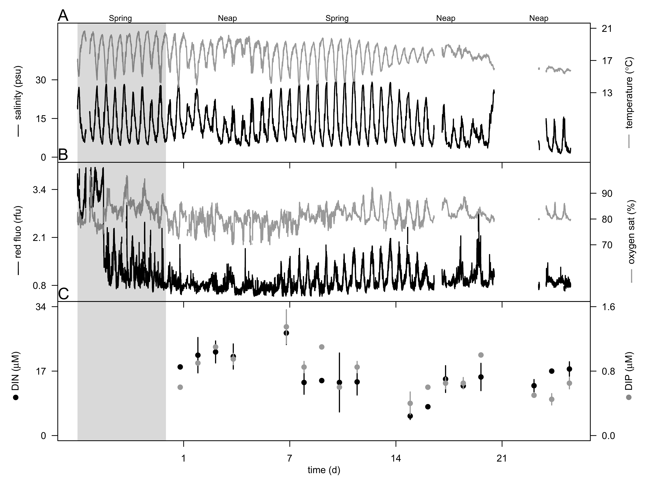

**Fig. 1** Hydrographic conditions prior and during the 4 week-survey in the Columbia River estuary at 2.4 m depth. A) Salinity (psu, black line) and temperature (ºC, grey line). B) Chlorophyll *a* concentration (rfu, black line) and oxygen saturation (%, grey line), and C) concentrations of dissolved inorganic nitrogen (DIN, µM, open circle) and phosphorus (DIP, µM, black circle). Vertical bars represent the ranges of nutrient concentrations. The grey region represents the week prior the start of the survey.



**Fig. 2** Flow cytometric signatures and micrograph of glutaraldehyde-fixed *Teleaulax*-like cryptophytes. A) Red fluorescence (692 nm wavelength) from chlorophyll versus forward light scatter (related to cell size) shows phytoplankton community structure, cryptophyte population (red dots, see right panel) and detritus (low red fluorescence) (left panel). Red fluorescence (692 nm wavelength) versus orange fluorescence (527 nm wavelength) from phycoerythrin uniquely identified a population of cryptophyte (red dots), and a tight peak of uniform fluorescent microspheres (grey circle) added as an internal standard (right panel). Cells with low orange fluorescence are the phytoplankton populations and detritus shown on the left panel. B) Micrographs using transmitted-light (left) and epifluorescence (right) microscopy after cell sorting by flow cytometry of the cryptophyte population (red dots shown in panel A). Scale bar is 5 µm.

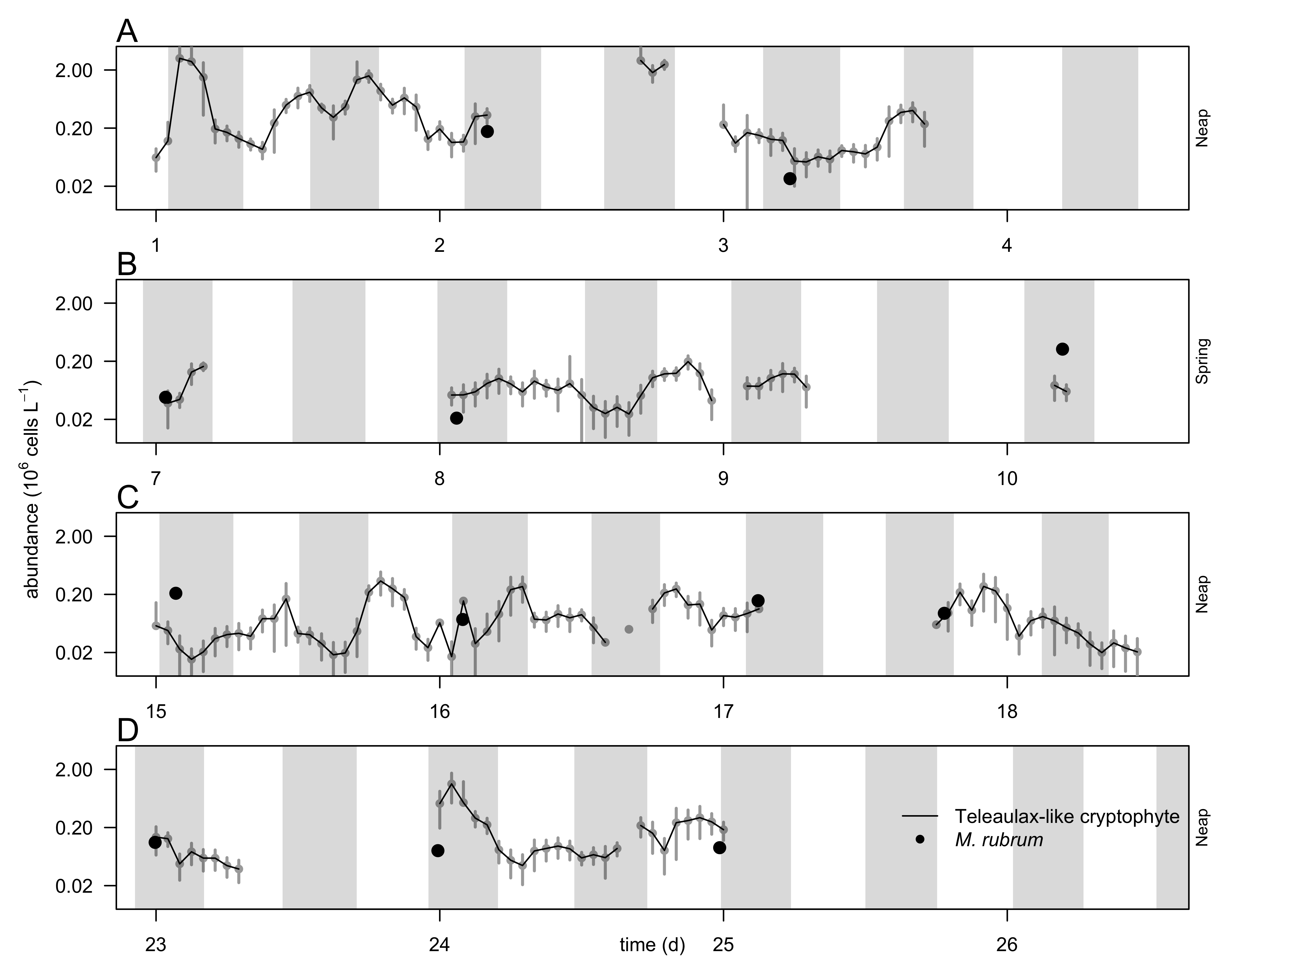**Fig. 3** Hourly-averaged cell abundances of *Teleaulax*-like cryptophytes(grey circles and black line, 106 cells L-1) determined by continuous flow cytometry and abundance of *Mesodinium rubrum* (black circles, 106 cells L-1) determined by automated microscopy from discrete samples taken during the 4-week survey (A-D, week 1-4). Note that abundances are plotted in log scale. Vertical bars represent the standard deviation of the hourly-mean cell abundance of *Teleaulax*-like cryptophytes(n=20). Grey regions represent flood tide.

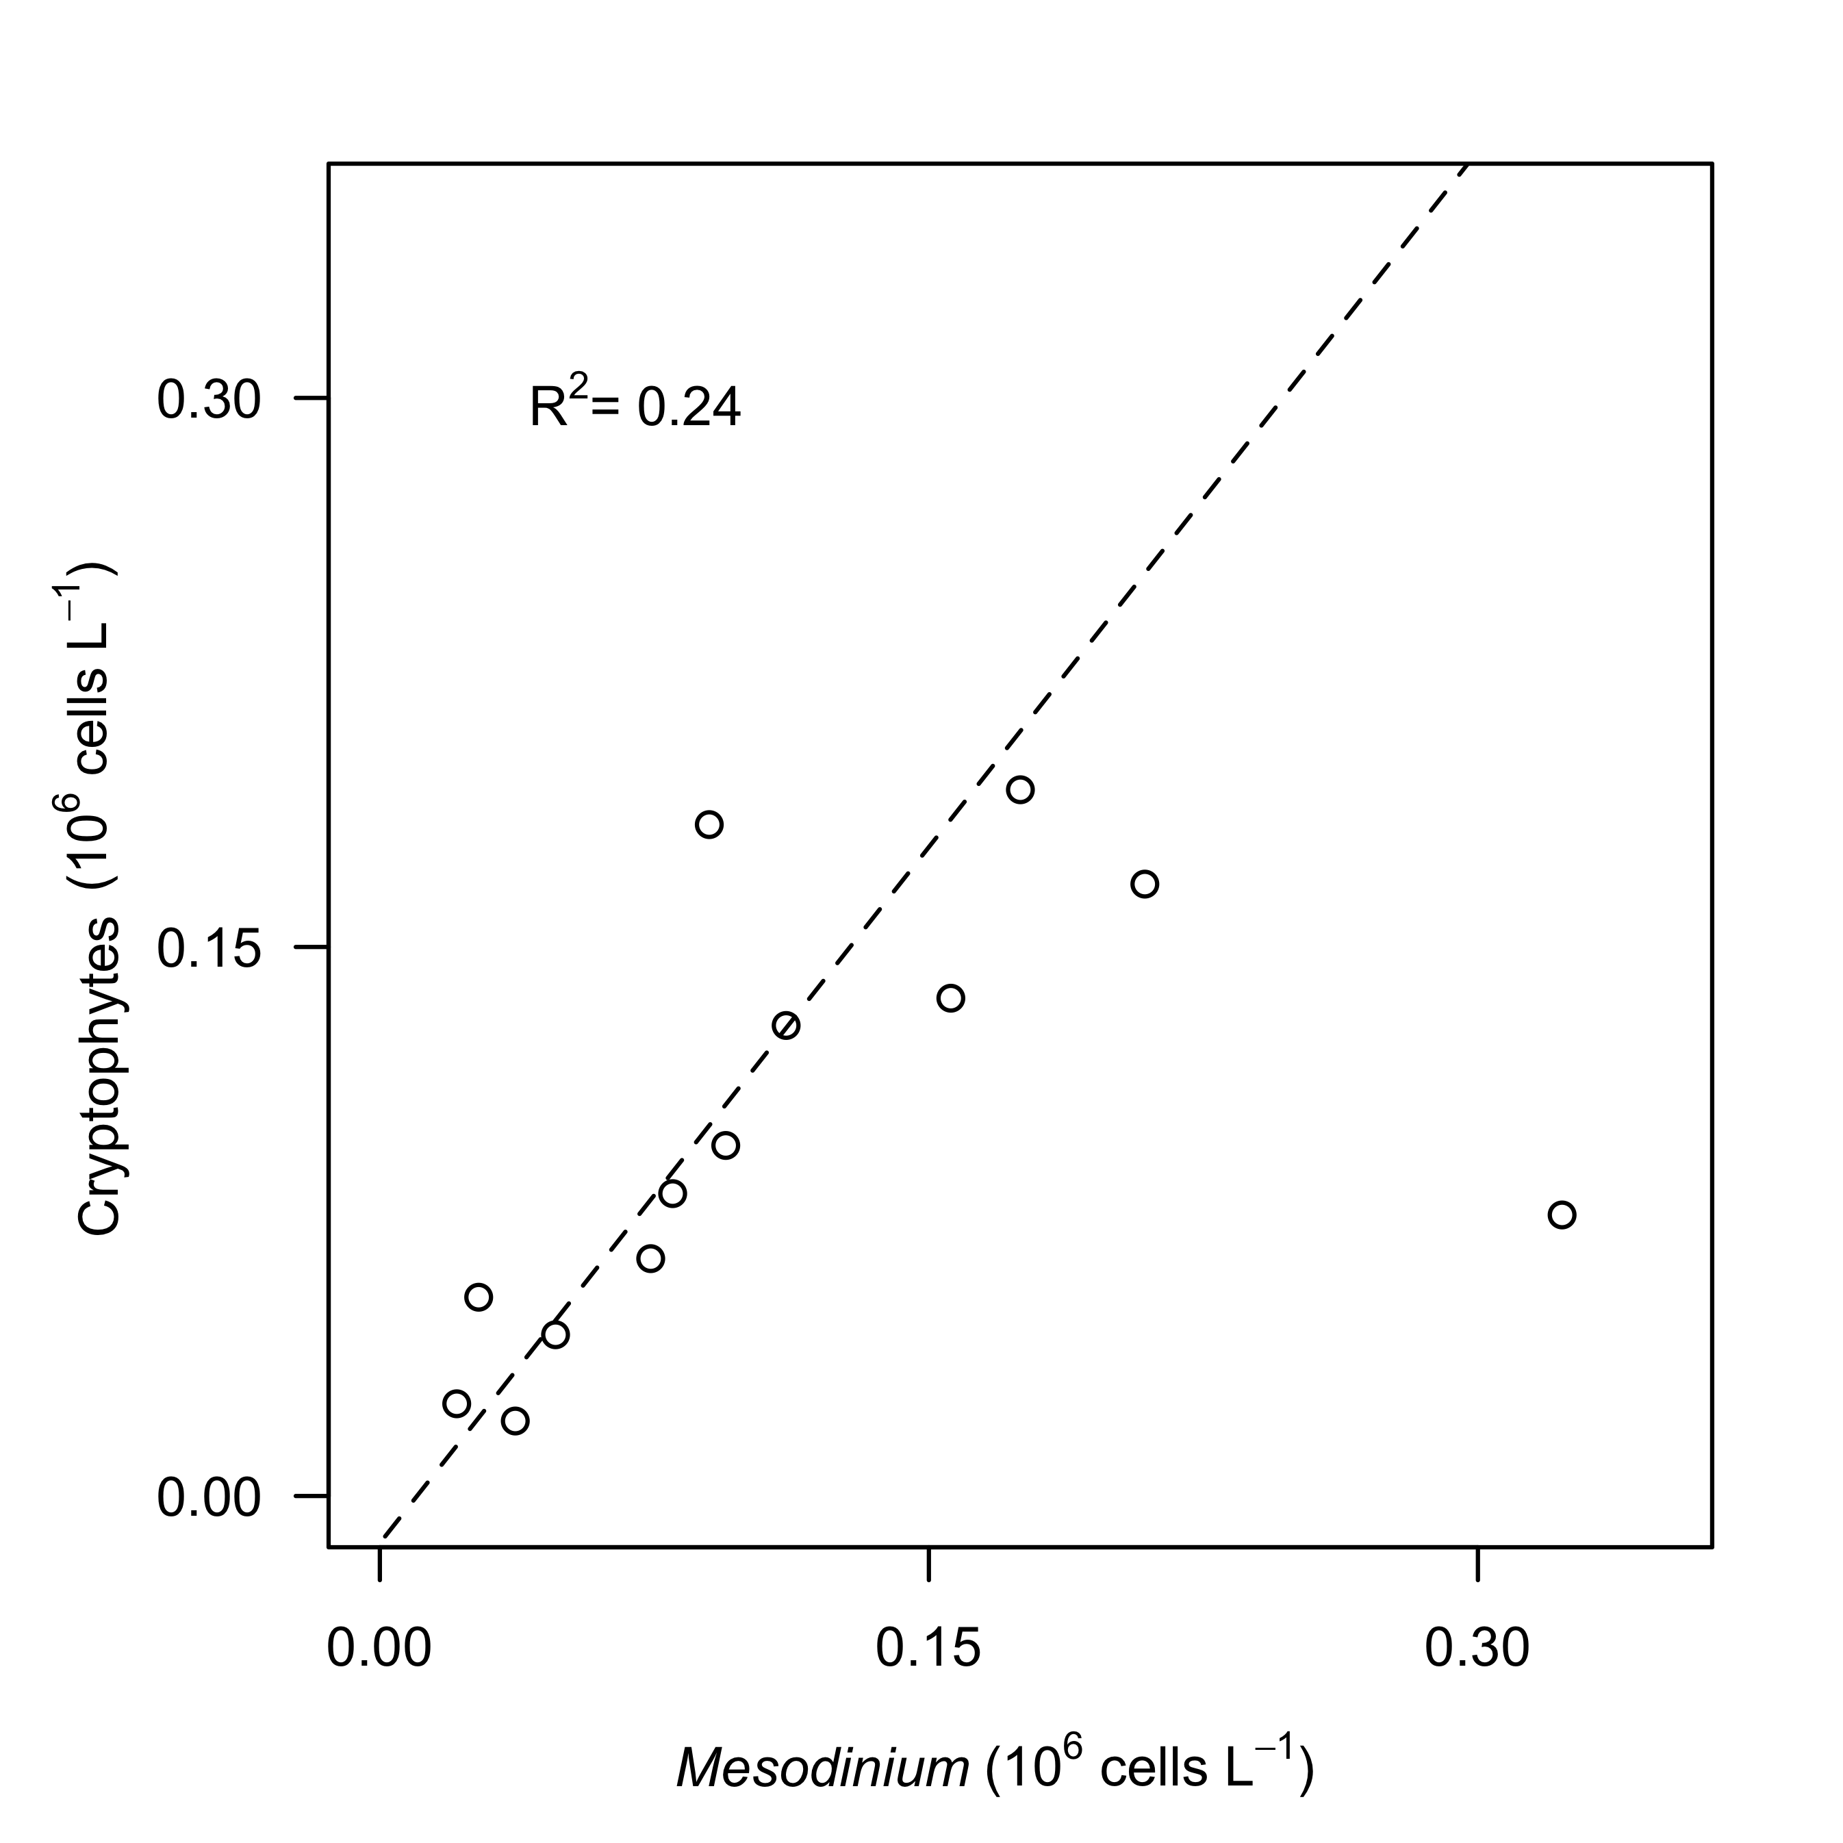

**Fig. 4.** Relationship between hourly-average cell abundances of *Teleaulax*-like cryptophytes (106 cells L-1)and *Mesodinium rubrum* (106 cells L-1) during the survey in the Columbia River estuary. Dashed lines represent model II linear regression of plotted data and R2 represents the coefficient of determination.

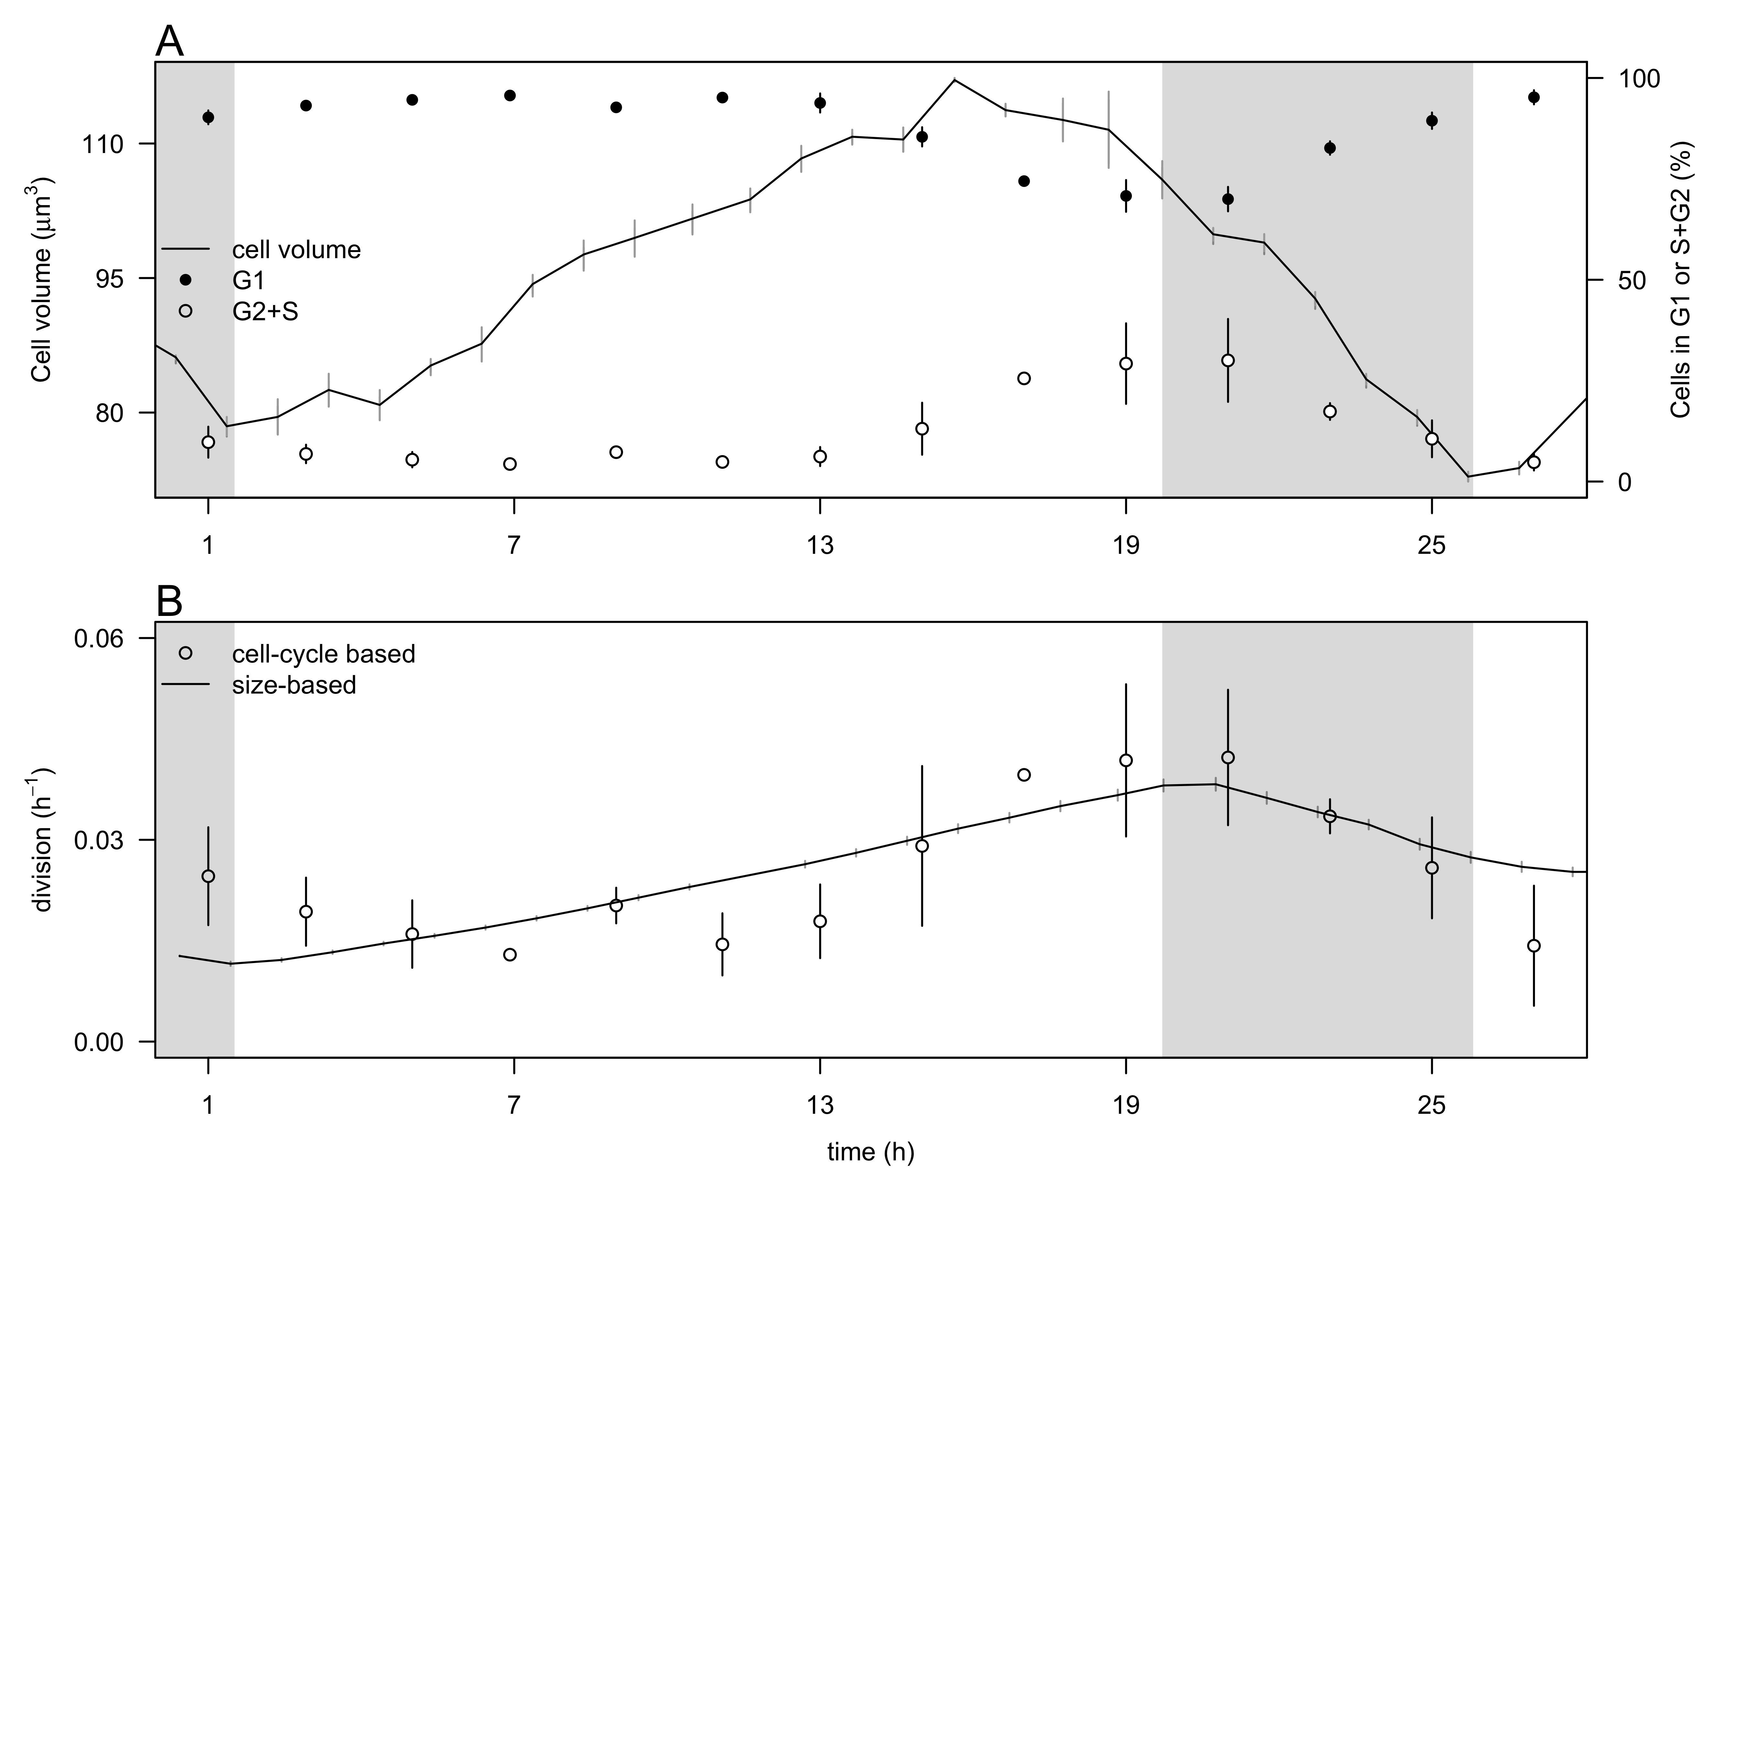

**Fig. 5.** Comparison of the size-based and cell-cycle based estimates of division rates for a cultured cryptophyte isolate during a 28-hr experiment.A) Hourly- averaged cell volume of *Rhodomonas sp.* (µm3, black line) and percentage of cells in G1 (close circles), and S+G2 (open circles) phases. B) Hourly division rates (h-1) based on the size distribution (black line) and on cell cycle analyses (open circles). The grey regions indicate night. Vertical bars represent standard error (n=20 for cell volume, n=3 for the percent of cells in G1 and S+G2 phases, n=24 for the size-based division rates).



**Fig. 6.** A) Hourly-averaged cell volumes of *Teleaulax*-like cryptophytes (µm3) estimated by flow cytometry during the survey. Vertical grey bars represent the standard deviation of the hourly-mean cell volume. The grey regions indicate night. B) Daily rates of cell division (d-1) of *Teleaulax*-like cryptophytesduring the survey. Vertical bars represent the propagated standard error of the sum of hourly division rate estimates during each of the ten 24 h-period.



**Fig. 7.** Relationship between division rates (d-1) of *Teleaulax*-like cryptophytes with daily-averaged concentrations of A) dissolved inorganic phosphate (DIP, µM) and B) dissolved inorganic nitrate (DIN, µM) during the survey. Dashed lines represent model II linear regression of plotted data and R2 represents the coefficient of determination.

*The following supplement accompanies the article*

**Dynamics of *Teleaulax* cryptophyte prey during the decline of red water blooms**

**in the Columbia River Estuary**

Maria Hamilton, Gwenn M. Hennon, Joseph Needoba, Katie Maxey, Rhonda Morales, Tawnya Peterson, Megan Schatz, Jarred Swalwell, Peter Zuber, E. Virginia Armbrust, Francois Ribalet *

* Corresponding author: [ribalet@uw.edu](mailto:ribalet@uw.edu)

**Supplement.**





**Fig. S1** Map of the Columbia River Estuary with the station SATURN-03 location (black dot).

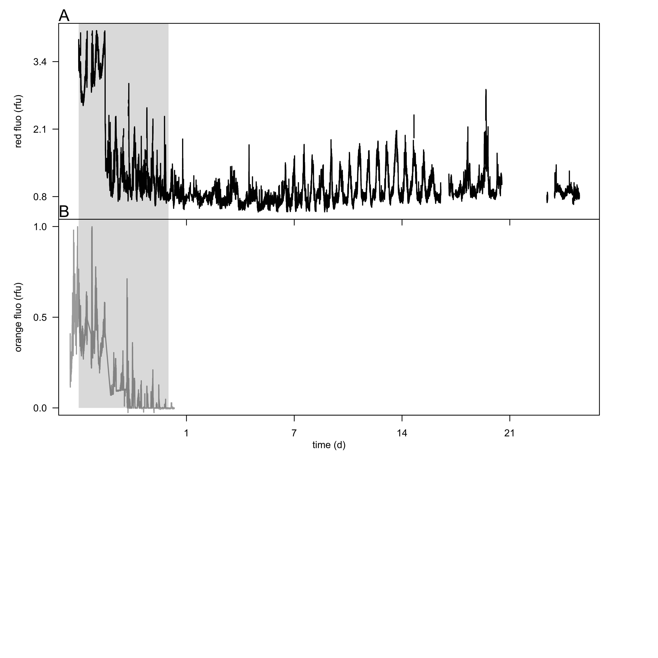

**Fig. S2**. Hydrographic conditions prior the 4 week-survey in the Columbia River estuary at 2.4 m depth. A) Chlorophyll *a* fluorescence (rfu) and B) phycoerythrin fluorescence (rfu). The grey region represents the week prior the start of the survey.



**Fig. S3.** Comparison of cell counts obtained with different methods. A) Cell abundances of *Teleaulax-*like cryptophytes (106 cells L-1) during the survey measured with the SeaFlow instrument (black line) and measured with a BD Influx cell sorter (black circles). B) Correlation of cell abundances measured by the two instruments. Dashed lines represent model II linear regression of plotted data and R2 represents the coefficient of determination.



**Fig. S4.** Comparison of size-based division rate estimates (h-1) with DNA-based estimates of division rates (h-1) of *Rhodomonas* sp. in cultures over the 28-hr time course experiment. Dashed lines represent model II linear regression of plotted data and R2 represents the coefficient of determination.